**Flow Meter Power Budget**

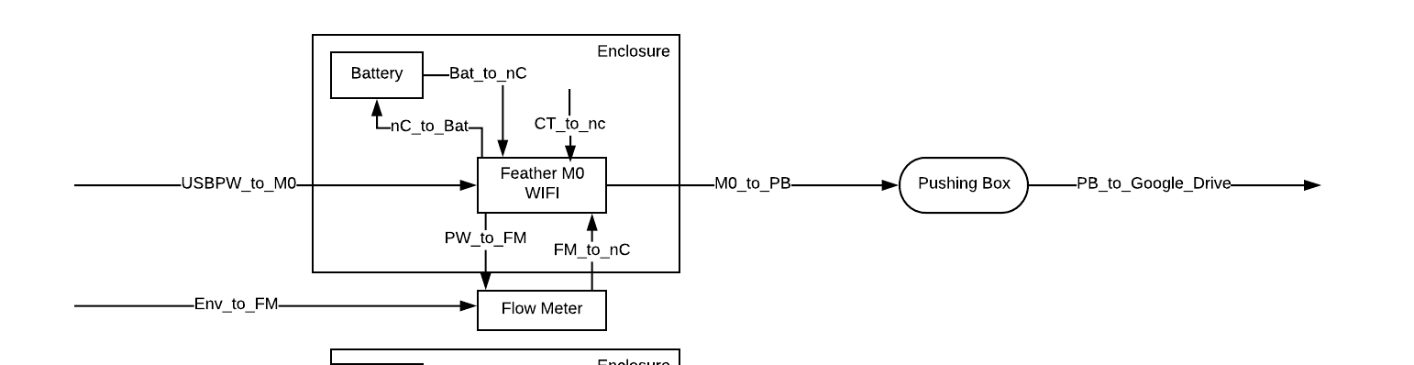

|  |  |
| --- | --- |
| **Item** | **Data** |
| Backup Battery | 3.7V,  2500mAh |
| Main Battery | 12 V  3000 mAh * 3 |
| nC | 5V,  100mA (10%), when WiFi is using  22mA (90%) |
| Flow Meter Sensor | 3V  20 mA |

**Calculation:**

* Power for each component
$P_{nC, WiFi}=5V×100mA=500mW$

$P_{nC, normal}=5V×22mA=110mW$

$P_{nC, total}=P_{nC, WiFi}+P_{nC, normal}=500mW+110mW=610mW$

$P_{Sensor}=3V×20mA=60mW$

* Average total power
$P_{Total}=P_{nC, total}+P_{Sensor}=610mW+60mW=670mW$

* Average total operation time

$I_{Total}=\frac{P_{Total}}{V_{operating}}=\frac{670mW}{3.3V}=203mA$

$t= \frac{capacity of battery}{I_{Total}}=\frac{9000mAh}{203mA}=44.3h$